Kiran Girish

Period 4

04/28/16

Djbouti dataset, uncrossing

Distance: 6810.967444875683

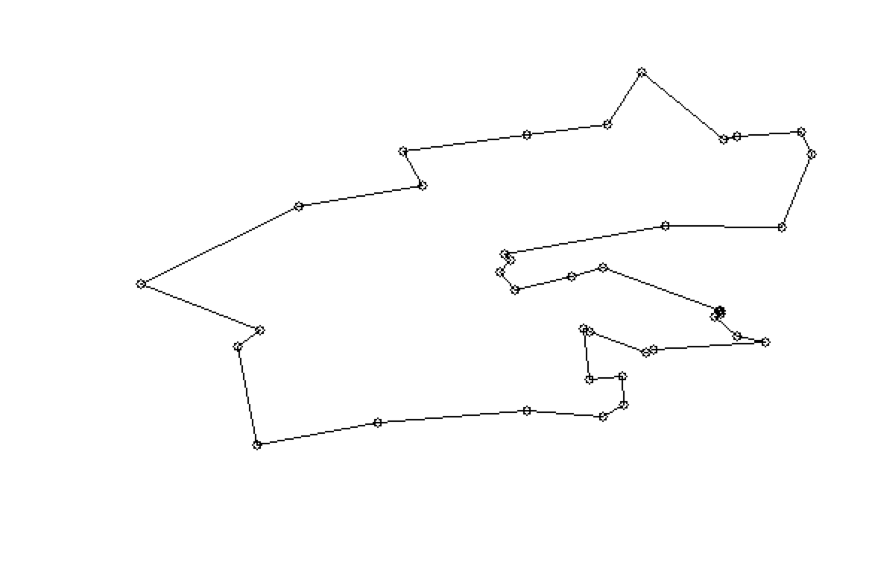

Path: [1, 2, 4, 3, 5, 7, 6, 15, 20, 23, 26, 25, 22, 24, 16, 12, 11, 17, 19, 18, 9, 8, 13, 28, 27, 31, 36, 34, 33, 38, 37, 35, 32, 30, 29, 21, 14, 10]